**Day 1 : 11 Nov 2024**

<https://www.google.com> URL : Unform Resource Locator

http/https(request)---🡪

Client Server

🡨--http/https(response) HTML/HTML5

Html is mainly use to create the web page. CSS/CSS3

Using CSS we can apply formatting style for web page.

JS

Using JS with help of DOM Parser. We can read, write and update DOM dynamically. In html page html, head, body, p, div, span all tags are known as dom elements.

Document object model.

**document.getElementById()**

**document.getElementsByTagName()**

**document.getElementsByNames();**

jQuery : jQuery is third party open source JS library which provided set of function which internally connected with each other to read, write and update dom properly.

Angular or React or Vue JS

These 3 above technologies support SPA concept. Single Page Application.

In SPA we load only part of web page rather than whole page.

Index.html welcome.html

Hyper link or button or submit button using backend technologies.

DOM hierarchy

Html

Head

Title

Meta

Style

Script

Body

Div p h1 to h6

Angular is an open source web framework. Framework provide set of api which internally connected with each other to perform specific. Framework internally follow Design pattern. But framework is complex. Angular internally follow MVC design pattern. Angular is part of google.

V -🡪 View : presentation logic.

C 🡪Controller intermediate between view and model

M 🡪 Model : business logic as well as database logic

React JS is an open source third party library. React JS is light weighted library which help to create UI components. In MVC react only focus on View part rather than Model and controller. React JS is part of Facebook.

If we want to make react js as a standard we use react with redux state management tool.

React JS support Virtual DOM.

In React JS we use component concept.

Component is use to control the view or part of view.

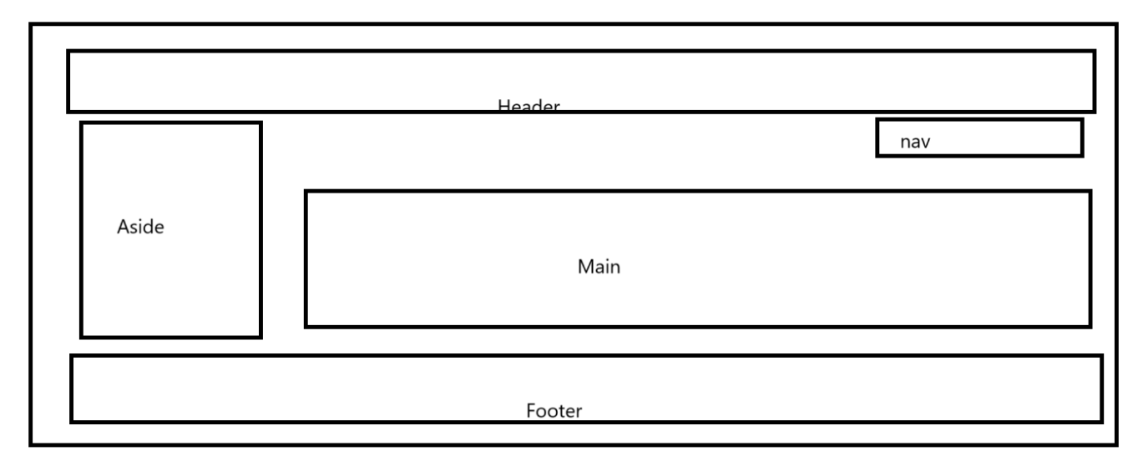

In react JS we are creating these component using

1. Function style component (ES5 style)
2. Class style component (ES6 style)
3. Arrow style component (ES6 style)

Node JS : Node JS is a run time environment for JavaScript library or framework or JS. Before Node JS JavaScript known as Client Side scripting language which we run on browser. But after node JS we can say JavaScript is client side as well as server side scripting language. Using node we can create server side programming language like python with Django or asp.net or php or java etc.

React JS internally use JSX. JSX JavaScript Syntax Extension.

Inside html we can write JS code. If we want to write html inside JS we need to use document.write(“<h1>Hello</h1>”);

But with help of JSX we can write dynamic html code inside JavaScript functions or script tags. This JSX can’t understand by normal browser. So we use babel. It is a type of transpiler which help to convert JSX to JS.

React JS provided React CLI (Command line interface) which help to create project template with pre-defined all configuration.

node --version

npm --version (node package manager). It is toolkit which help to download external module

npm install -g create-react-app

or

sudo npm install -g create-react-app (non window user)

create-react-app –-version

create-react-app welcome-app welcome-app is my project name.

cd welcome-app it is use to move inside a project folder.

npm start this command is use to run the project..

it will open in default browser with URL as <http://localhost:3000>

we need to open this project in IDE ie VS Code.

Open the VS code and select the option as file and open the folder. Then select react-js project ie welcome-app.

Below is the project structure

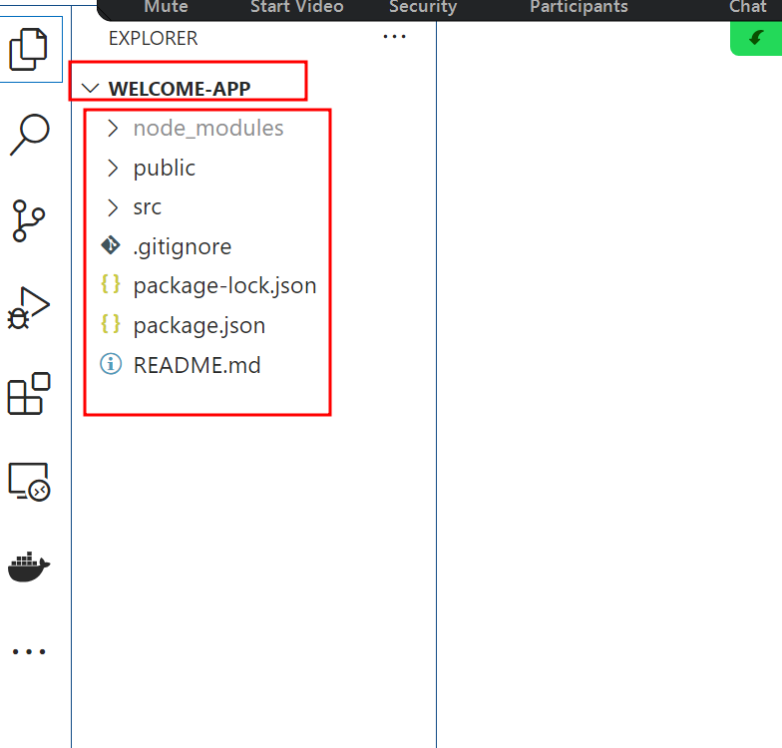

Inside src folder. Please open app.js file

In React JS we can create component using one of the way with help of functions.

Function name must be follow pascal naming rule. If function contains one word first letter upper case. If it contains more than one word then each word first letter upper case.

Using component in react JS we are creating user defined tags.

<p>Hello</p> this is paragraph tag which is use to display the content on web page

<h1>heading content</h1>

React JS provided two module

1. React : react module is use to create component. These all component are part of virtual DOM.
2. ReactDOM : react dom help to provide bridge or render the data from virtual DOM to actual DOM.